# Fossil-Bison latifrons

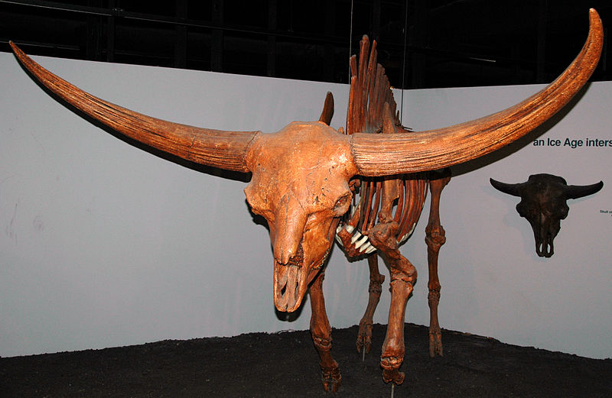

Bison latifrons Harlan, 1825 fossil buffalo skeleton from the Pleistocene of North America (public display, Cincinnati Museum of Natural History & Science, Cincinnati, Ohio, USA).

The extinct giant buffalo, Bison latifrons, was remarkable in having horns with a >3 times longer span than the modern American buffalo (Bison bison). The overall body size of the giant buffalo was also considerably larger than modern buffalo.

Classification: Animalia, Chordata, Vertebrata, Mammalia, Artiodactyla, Bovidae

